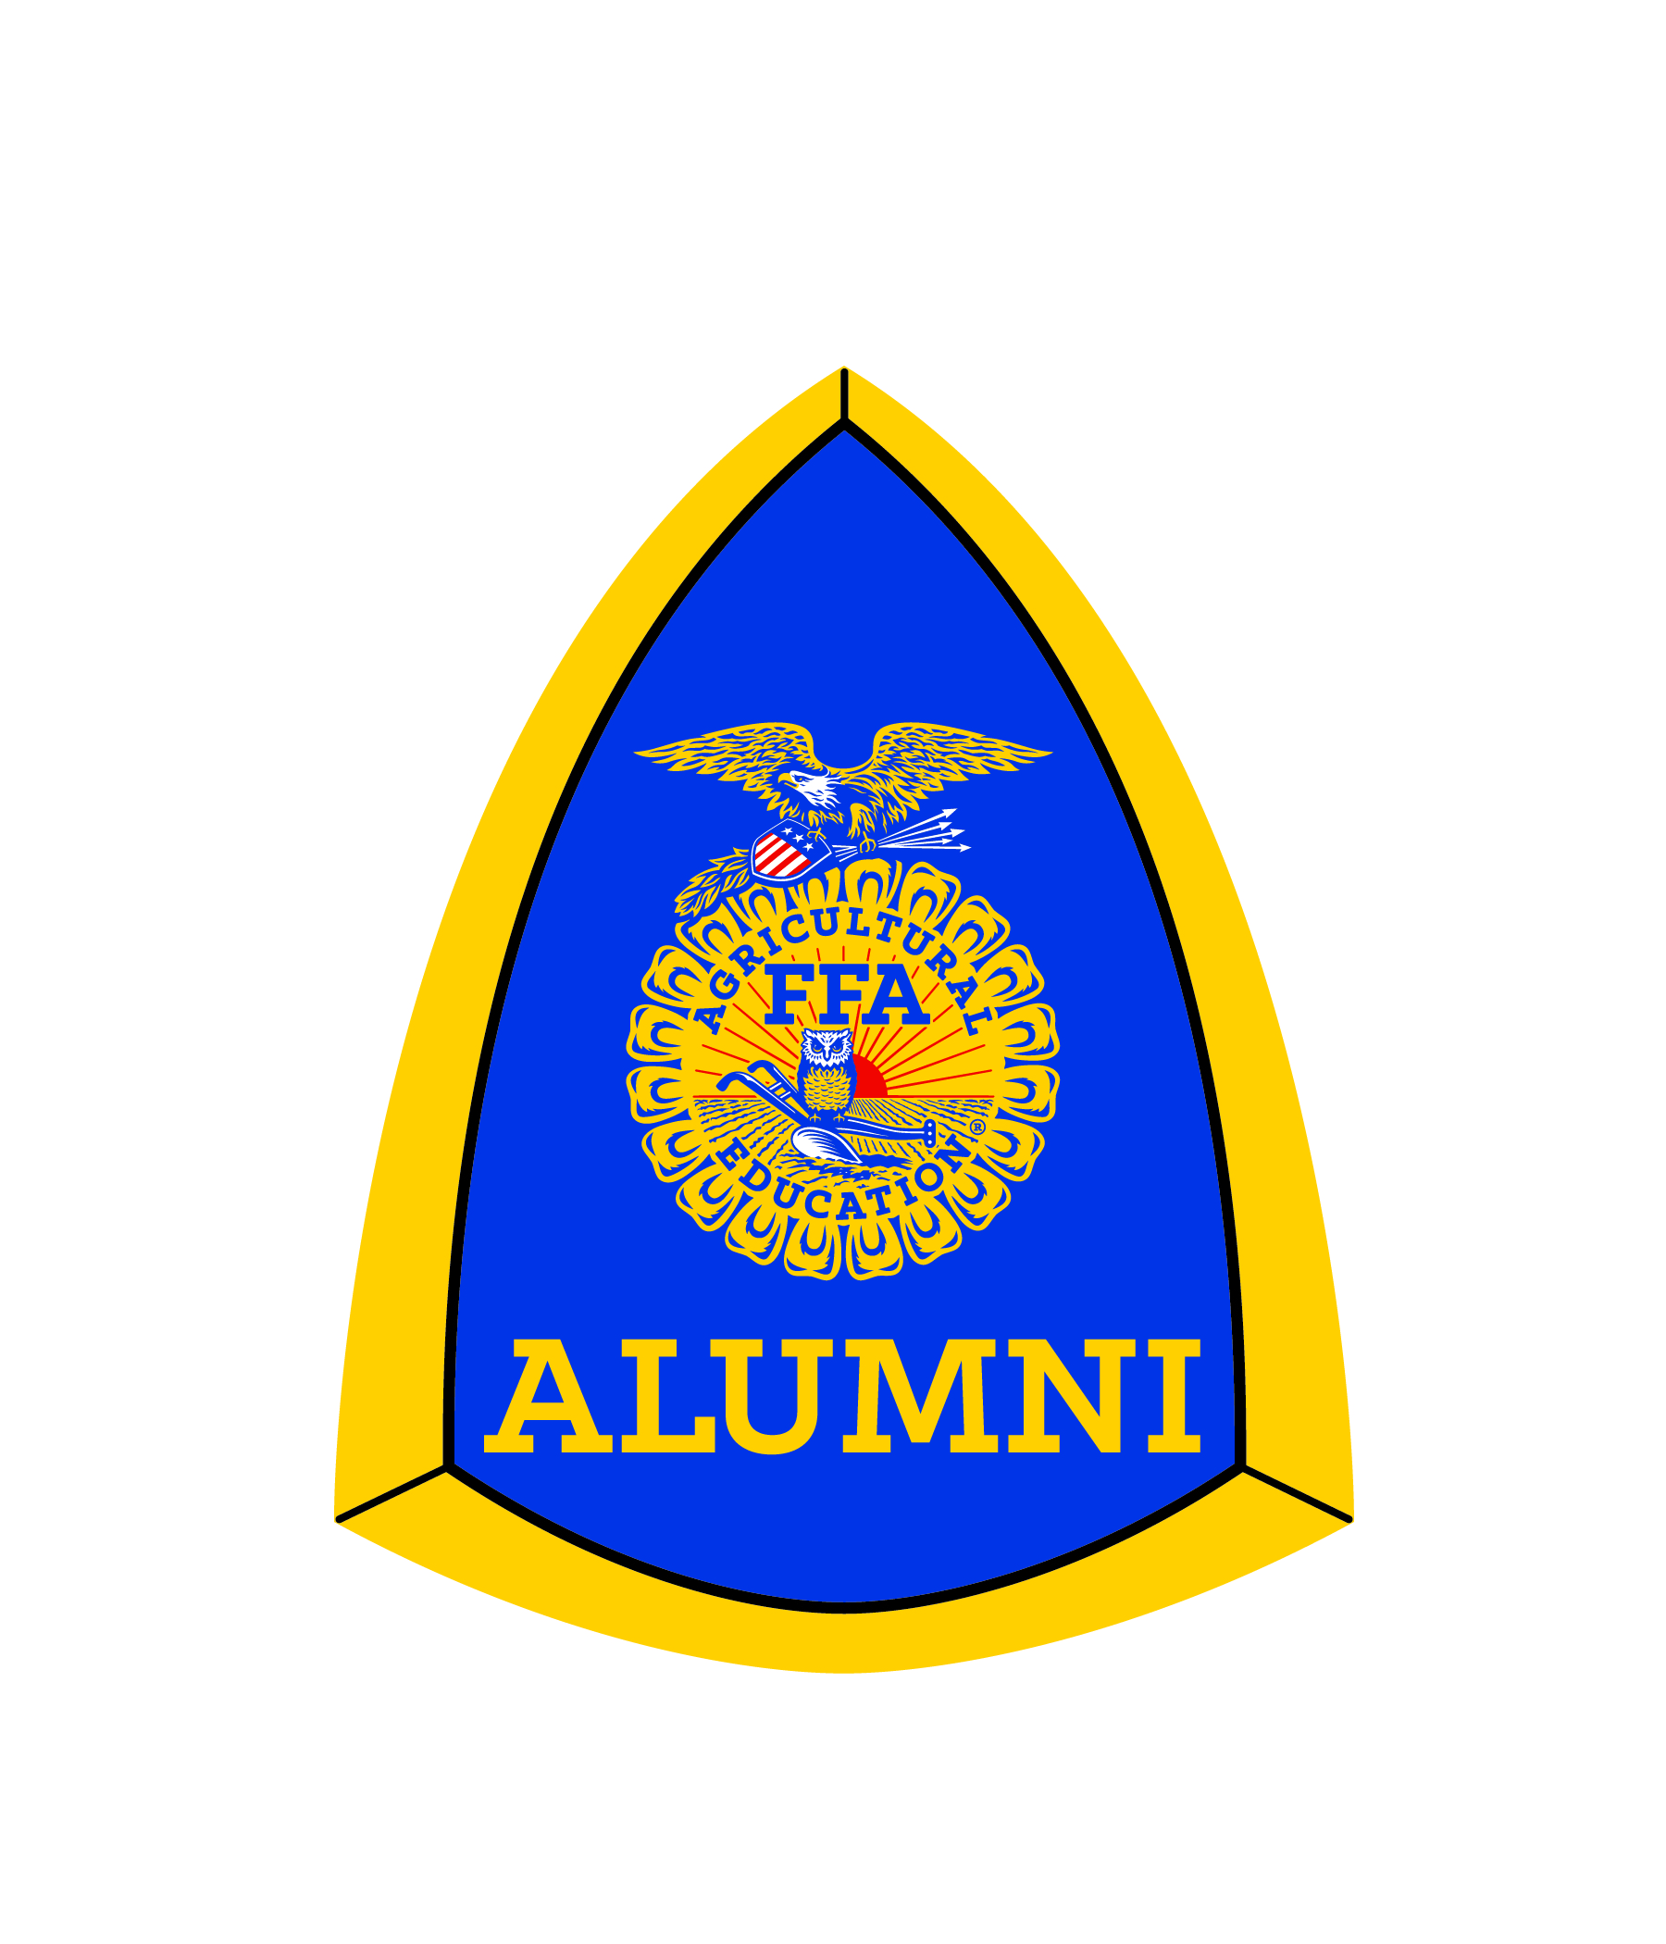
Name of Nominee:
Address: City: Zip:
Phone: Email:
Has nominee been an Agriculture Educator? Alumni Affiliate:

FFA Alumni Activities (Include activities at all levels; specifying local, state and national)

Community Service Activities and Awards

List how the nominee advocates for FFA and Agriculture Education

Provide a one page summary on how the nominee has demonstrated outstanding service to the FFA and Alumni Community. Use 12 inch simple themed font, single space. Please use numbers (years, students and teams, etc.) and amounts when possible. Make sure the application, itself, is only two pages. However, supporting items such as newspaper articles are allowed to be included. Unsigned applications will not be considered. Include hard copy 4x6 photo of nominee with application (no computer printed pictures will be accepted).
Service denotes contributions of time, expertise, talent, money or sacrifices made beyond the expectations of the job or elected position. Advocacy refers to efforts made to sustain and promote agriculture, agriculture educations, FFA and FFA Alumni.
One recipient from each Florida FFA Association Area will be recognized at the Florida FFA State Convention in June. From those six individuals the top three will be announced. The winner will receive a paid registration to the State Alumni Conference and a plaque.

Nomination submitted by:
(Printed name) (Signature)

Email: Phone: __________________________

Local Alumni President:
(Printed name) (Signature)

Applications are to be postmarked by April 2nd and mailed to Florida FFA 5600 SW 43th St Gainesville, FL 32608. Unsigned applications will be disqualified. Nominee must be an active alumni member.

