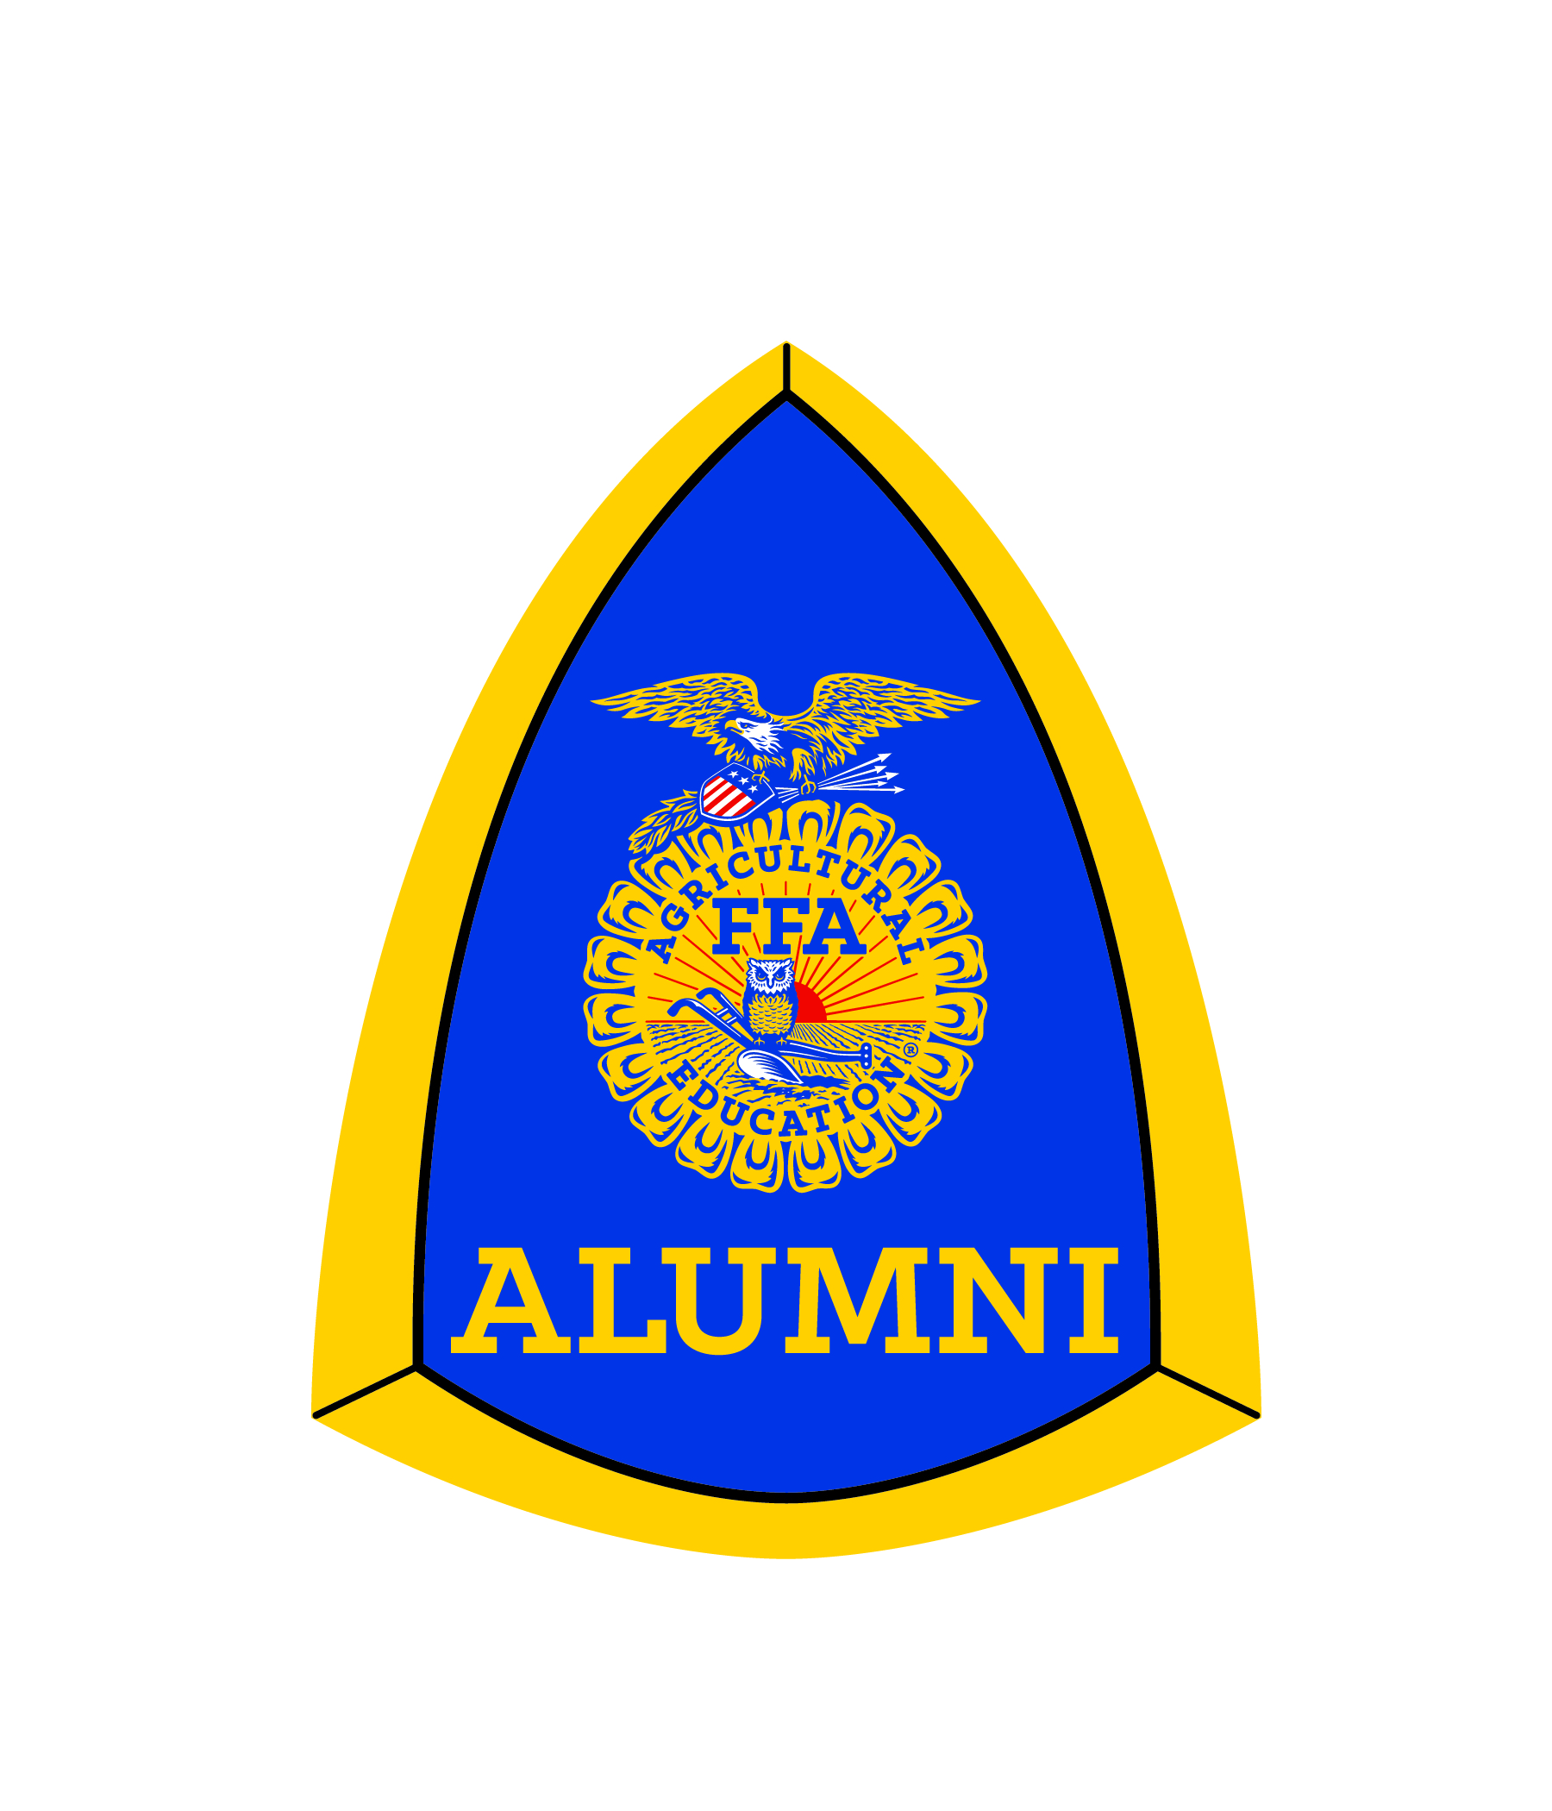
FLORIDA FFA ALUMNI & SUPPORTERS
2018 OUTSTANDING ACHIEVEMENT AWARD
Name of Nominee:
Address: City: Zip:
Phone: Email:
Has nominee been an Agriculture Educator? Alumni Affiliate:

FFA Alumni Activities (Include activities at all levels; specifying local, state and national)

Community Service Activities and Awards

List how the nominee advocates for FFA and Agriculture Education

FLORIDA ALUMNI & SUPPORTERS
OUTSTANDING ACHIEVEMENT AWARD

Provide a one page summary on how the nominee has demonstrated outstanding service to the FFA and Alumni Community. Use 12 inch simple themed font, single space. Please use numbers (years, students and teams, etc.) and amounts when possible. Make sure the application, itself, is only two pages. However, supporting items such as newspaper articles are allowed to be included. Unsigned applications will not be considered. Include hard copy 4x6 photo of nominee with application (no computer printed pictures will be accepted).
Service denotes contributions of time, expertise, talent, money or sacrifices made beyond the expectations of the job or elected position. Advocacy refers to efforts made to sustain and promote agriculture, agriculture educations, FFA and FFA Alumni.
One recipient from each Florida FFA Association Area will be recognized at the Florida FFA State Convention in June. From those six individuals the top three will be announced. The winner will receive a paid registration to the State Alumni Conference and a plaque.

Nomination submitted by:
(Printed name) (Signature)

Email: Phone: __________________________

Local Alumni President:
(Printed name) (Signature)

Applications are to be postmarked by May 1st and mailed to Doug Register at 8316 Claude Harvey Rd. Glen St. Mary, FL 32040. Unsigned applications will be disqualified.

